FitLux – Luxury Fitness E-Commerce Platform (Backend-First Design)

Project Requirements & Solution Design Document

Document Control

Field | Details
Project Name | FitLux – Luxury Fitness E-Commerce Platform
Document Version | 1.0
Date | January 15, 2026
Status | Draft – Pending Client Approval
Prepared By | Prashant
Reviewed By | Prashant
Approved By | Krishna – Pending
Last Updated | January 15, 2026

Table of Contents
- Executive Summary
- Introduction
- Business Objectives
- Scope of Work
- Business Features & Capabilities
- Technical Architecture
- Security & Compliance
- Project Timeline & Phases
- Deliverables
- Assumptions & Dependencies
- Risks & Mitigation
- Success Criteria
- Budget & Resource Plan
- Sign-Off

1. Executive Summary
FitLux is a premium fitness e-commerce platform designed to deliver a luxury shopping experience for high-end fitness products including supplements, gym apparel, and accessories. The platform will be built with an API-first architecture using Spring Boot (Backend) and Angular (Frontend), providing role-based access for both administrators and end customers.

Key Highlights
- Premium Brand Positioning: Luxury-first design catering to health-conscious, affluent customers
- Dual-Mode Platform: Separate Admin (CMS) and Customer (Storefront) experiences
- Scalable Architecture: Modern microservice-ready backend with RESTful APIs
- Secure & Compliant: JWT-based authentication, role-based access control, PCI-DSS ready payment integration

2. Introduction

2.1 Purpose
This document outlines the complete requirements, technical design, and implementation roadmap for the FitLux platform. It serves as the single source of truth for stakeholders, development teams, and quality assurance.

2.2 Problem Statement
The premium fitness market lacks e-commerce platforms that combine:
- High-quality product curation
- Luxury brand experience
- Seamless admin operations
- Secure, mobile-friendly customer journeys
FitLux addresses this gap by providing an end-to-end solution tailored for premium fitness retail.

2.3 Target Audience
- Primary: Fitness enthusiasts aged 25-45 with high disposable income
- Secondary: Professional athletes, gym owners, wellness influencers

3. Business Objectives
Objective | Key Result
Launch MVP | Platform live within 10 weeks
User Acquisition | 1,00+ registered users in first quarter
Revenue Target | Depends on Brand growth
Operational Efficiency | Admin can manage 50+ SKUs independently
Customer Satisfaction | 4.5+ star rating, <2% return rate

4. Scope of Work

4.1 In-Scope
- User authentication & role management
- Product catalog (categories, brands, variants)
- Shopping cart & wishlist
- Checkout & payment integration
- Order management & tracking
- Admin dashboard for inventory & orders
- Coupon & discount engine
- Responsive Angular frontend
- RESTful API backend with Spring Boot

4.2 Out-of-Scope (Future Phases)
- Mobile native apps (iOS/Android)
- AI-based product recommendations
- Subscription/recurring orders
- Multi-vendor marketplace
- Loyalty points program
- Social media integrations

5. Business Features & Capabilities

5.1 Admin Features
Feature | Description | Priority
Product Management | Create/edit products with variants (size, flavor, color), pricing, stock, images | P0
Category Management | Organize products into categories and subcategories | P0
Order Management | View all orders, update status (Placed → Packed → Shipped → Delivered), process cancellations/refunds | P0
User Management | View registered users, activate/deactivate accounts, view purchase history | P1
Inventory Tracking | Real-time stock updates, low-stock alerts | P1
Coupon Management | Create discount codes, define rules (min order value, category-specific) | P1
Analytics Dashboard | Sales reports, top products, revenue metrics | P2

5.2 Customer Features
Feature | Description | Priority
User Registration & Login | Secure signup/login with email verification | P0
Product Browsing | Browse by category, filter by price/brand/rating, search functionality | P0
Product Details | View images, descriptions, reviews, variant selection | P0
Shopping Cart | Add/remove items, update quantities, view cart total | P0
Wishlist | Save products for later | P1
Checkout | Address management, order summary, payment integration | P0
Order Tracking | View order history, track shipment status | P0
Profile Management | Update personal info, manage addresses | P1
Product Reviews | Rate and review purchased products | P2

6. Technical Architecture

6.1 Technology Stack
Layer | Technology | Justification
Frontend | Angular 17+ | Modern SPA framework, TypeScript support
Backend | Spring Boot 3.x (Java 17) | Enterprise-grade, mature ecosystem
Database | MySQL | Relational, ACID-compliant, open-source
Authentication | JWT + Spring Security | Stateless, secure, scalable
Payment Gateway | Razorpay / Stripe | PCI-DSS compliant, easy integration
File Storage | AWS S3 / Cloudinary | Scalable image hosting
Deployment | Docker + Kubernetes | Containerized, cloud-agnostic
CI/CD | GitHub Actions / Jenkins | Automated testing & deployment

6.2 Architecture Diagram
Will be added in Next Document revision

6.3 API Design Principles
- RESTful: Standard HTTP methods (GET, POST, PUT, DELETE)
- Versioned: /api/v1/ for future compatibility
- DTO Pattern: No direct entity exposure
- Stateless: JWT tokens for authentication
- Pagination: For list endpoints (products, orders)

7. Security & Compliance

7.1 Authentication & Authorization
- JWT-based authentication (stateless)
- Role-based access control (RBAC):
  - /api/admin/** → ADMIN only
  - /api/user/** → Authenticated users
  - /api/public/** → Open access
- Password hashing using BCrypt

7.2 Data Protection
- HTTPS enforced for all communications
- SQL Injection prevention via prepared statements
- XSS Protection via Angular sanitization

7.3 Payment Security
- PCI-DSS compliant gateway (Razorpay/Stripe)
- No card data storage on servers
- 3D Secure authentication support

8. Project Timeline & Phases
 | Phase | Duration | Deliverables | Milestones
Phase 1: Foundation |  | Week 1-2 | Project setup, database schema, auth module | Dev environment ready
Phase 2: Core Backend |  | Week 3-6 | Product, cart, order APIs | Postman collection complete
Phase 3: Admin Panel |  | Week 7-9 | Admin dashboard, CRUD operations | Admin can manage catalog
Phase 4: Customer Frontend |  | Week 10-13 | Angular storefront, checkout flow | End-to-end shopping works
Phase 5: Integration |  | Week 14 | Payment gateway, email notifications | Orders can be placed
Phase 6: Testing & QA |  | Week 15 | Bug fixes, security audit, performance testing | UAT sign-off
Phase 7: Deployment |  | Week 16 | Production deployment, monitoring setup | Platform goes live

9. Deliverables

9.1 Technical Deliverables
- Source code (GitHub repository)
- API documentation (Swagger/OpenAPI)
- Database schema & migration scripts
- Deployment scripts (Docker Compose, Kubernetes manifests)
- Unit & integration test suites (80%+ coverage)

9.2 Documentation
- User manual (Admin & Customer)
- API reference guide
- Deployment & maintenance guide
- Security best practices document

9.3 Training & Support
- 2 training sessions for admin users
- 30 days post-launch support
- Bug-fix warranty (3 months)

10. Assumptions & Dependencies

Assumptions
- Client provides brand assets (logo, color palette) by Week 2
- Payment gateway account will be set up by client before Phase 5
- Product catalog data (initial 50 products) provided by Week 4
- Client has access to cloud hosting (AWS/GCP/Azure)

Dependencies
- Third-party APIs: Payment gateway, SMS/email service
- SSL certificate provisioning
- Domain name registration

11. Risks & Mitigation
Risk | Impact | Probability | Mitigation
Payment gateway integration delays | High | Medium | Start integration early, have backup provider
Scope creep | High | High | Strict change request process, signed approval needed
Performance issues at scale | Medium | Low | Load testing in Phase 6, caching strategy
Security vulnerabilities | High | Low | Security audit, penetration testing before launch
Key developer attrition | Medium | Low | Knowledge sharing, documentation

12. Success Criteria

Technical Success
- 99.9% uptime in first 3 months
- Page load time <3 seconds
- Zero critical security vulnerabilities
- API response time <500ms (95th percentile)

Business Success
- Platform handles 100 concurrent users
- Admin can process 50+ orders/day independently
- Customer can complete checkout in <2 minutes
- Mobile responsive (works on iOS/Android browsers)

13. Budget & Resource Plan

13.1 Team Composition
- Backend Developer (Spring Boot)
- Frontend Developer (Angular)

13.2 Estimated Budget
Category | Cost (INR)
Development | 10,000 (Front end engineer)
Design | % based margin
QA & Testing | % based margin
Infrastructure | As per Domain cost
Third-party services | As per Payment Gateway services

Customer Journey
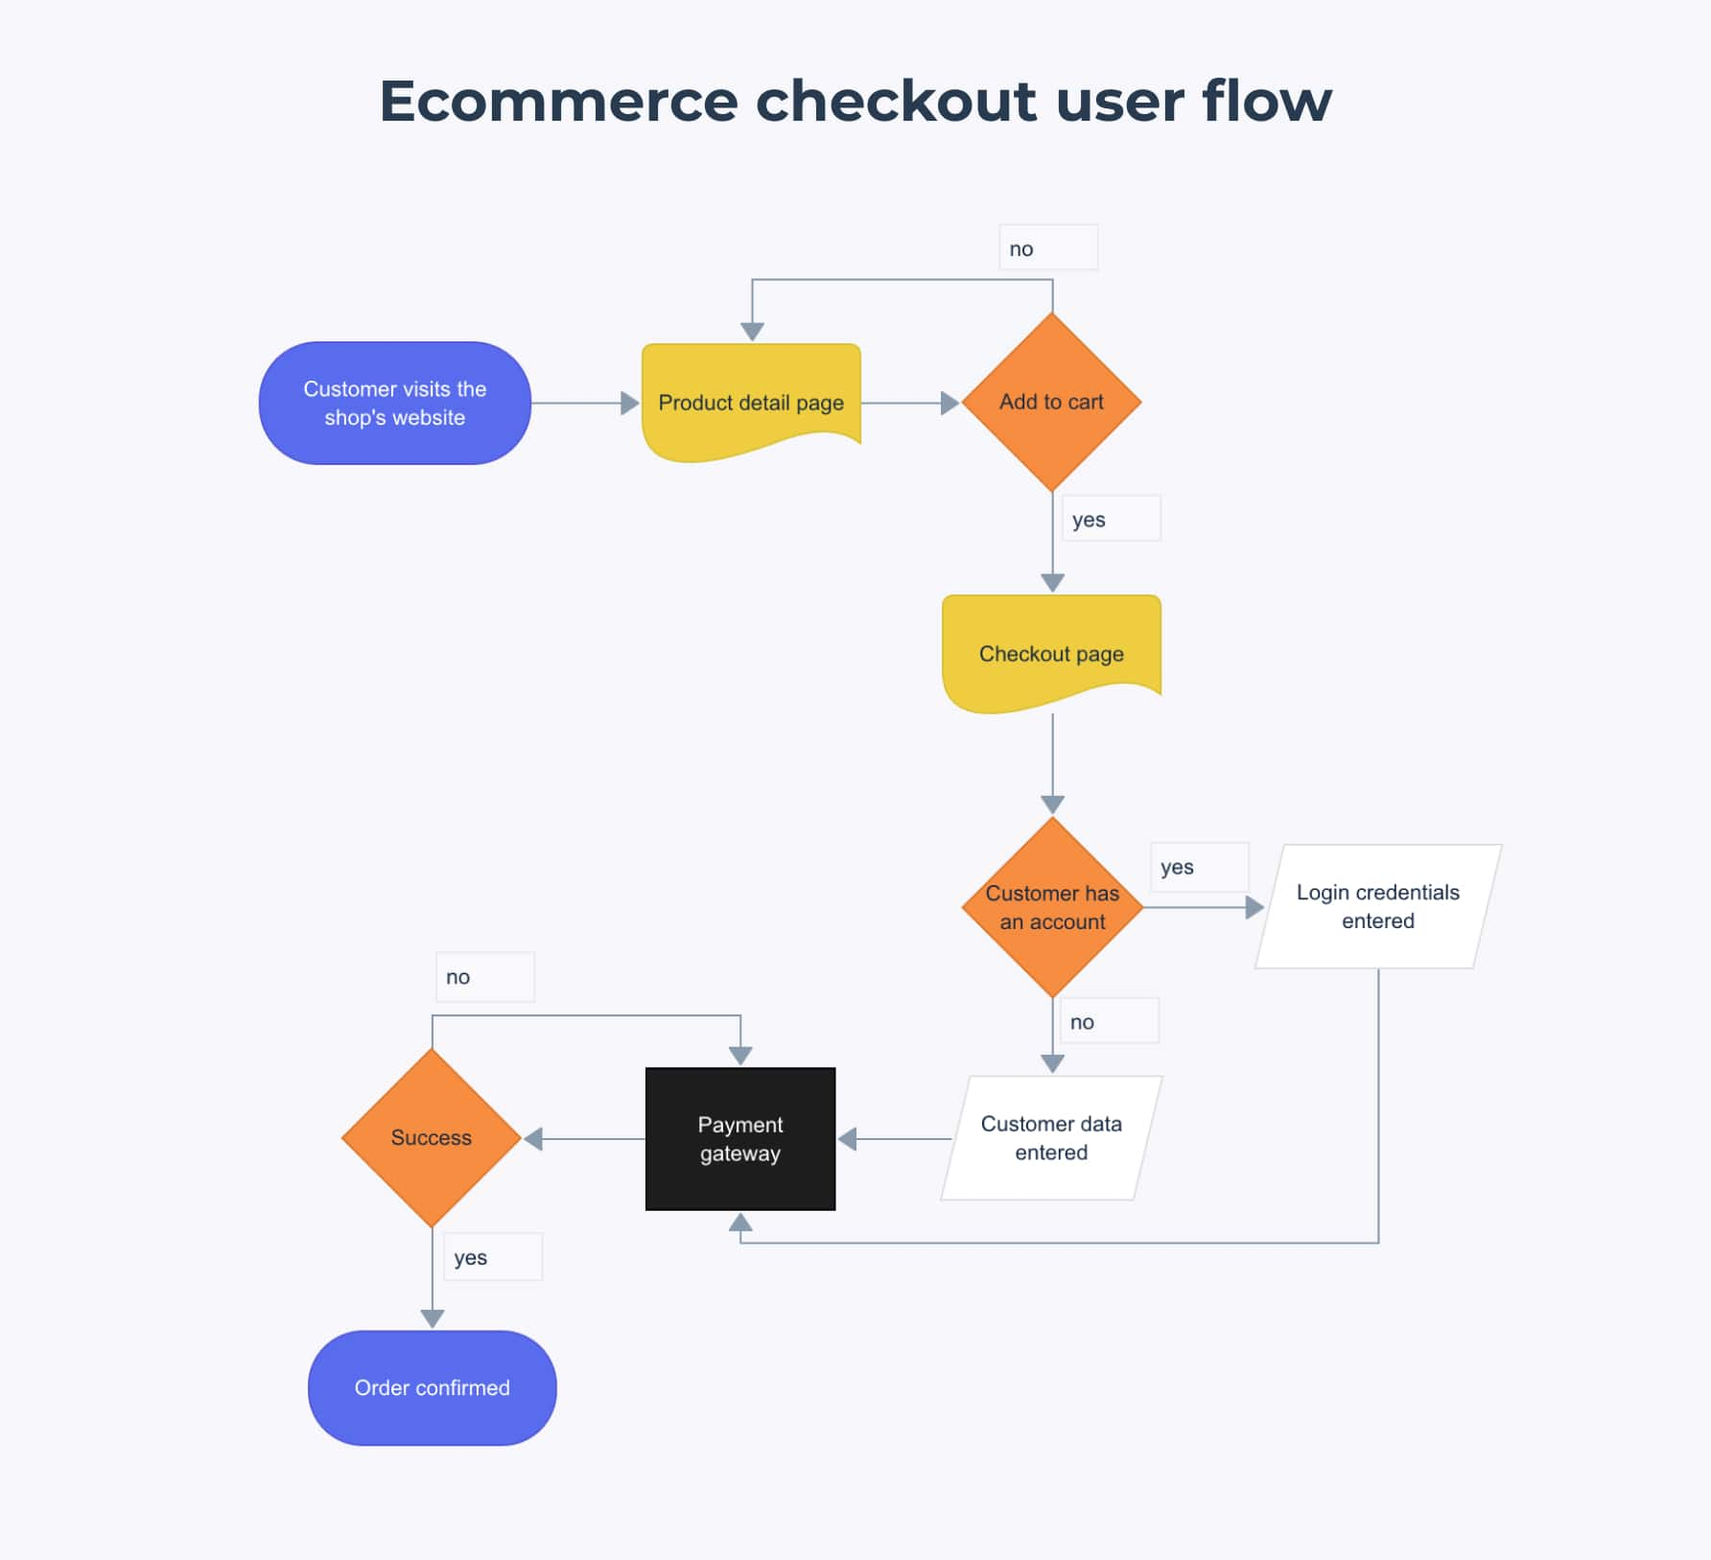

Admin Journey

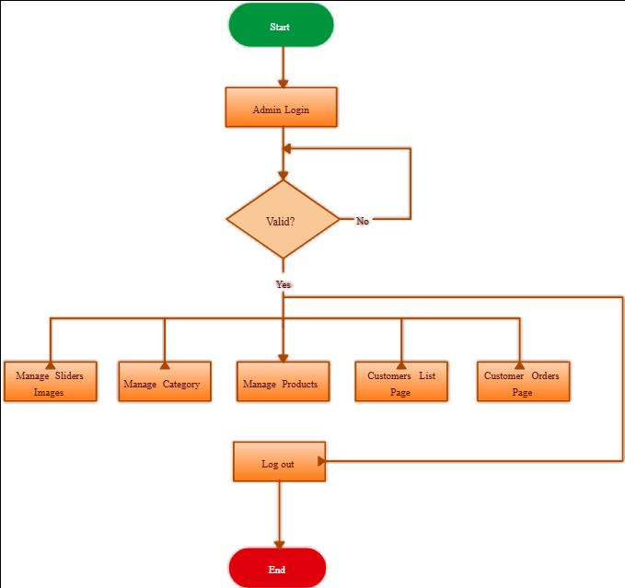

15. Sign-Off
By signing below, all parties agree to the scope, timeline, and budget outlined in this document.
Role | Name | Signature | Date
Client Representative
Project Manager | Prashant | PN | Jan 15, 2026
Technical Lead | Prashant | PN | Jan 15, 2026

Revision History
Version | Date | Author | Changes
1.0 | Jan 15, 2026 | Prashant | Initial draft

End of Document

